Install nginx 1.23 using source code on centos 7

wget <http://nginx.org/download/nginx-1.23.1.tar.gz>

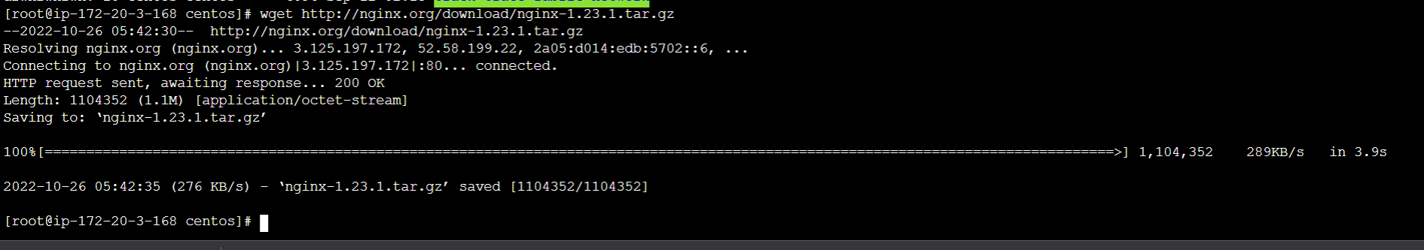

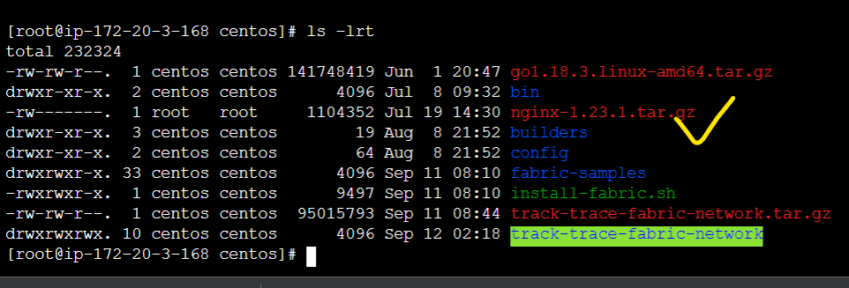

yum groupinstall " Development Tools" -y

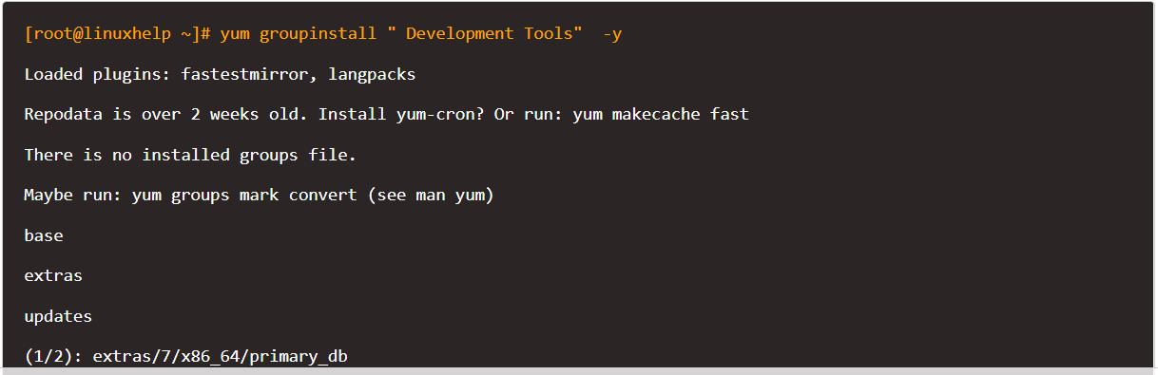

yum install zlib-devel pcre-devel openssl-devel -y

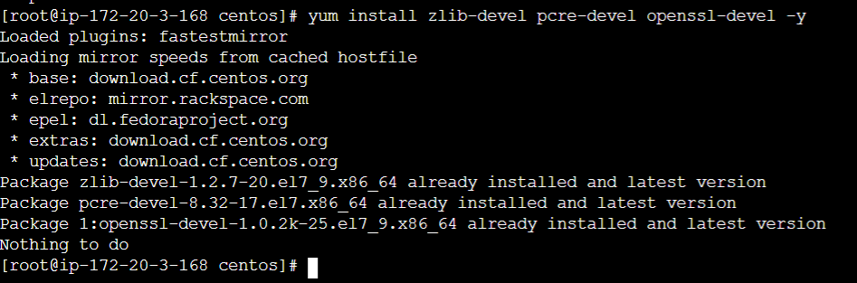

yum install epel-release -y

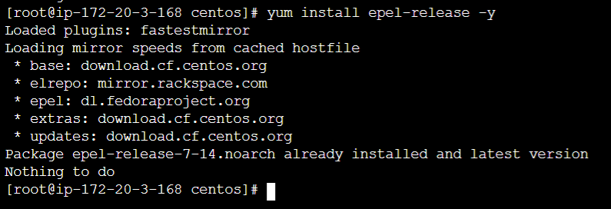

yum install perl perl-devel perl-ExtUtils-Embed libxslt libxslt-devel libxml2 libxml2-devel gd gd-devel GeoIP GeoIP-devel -y

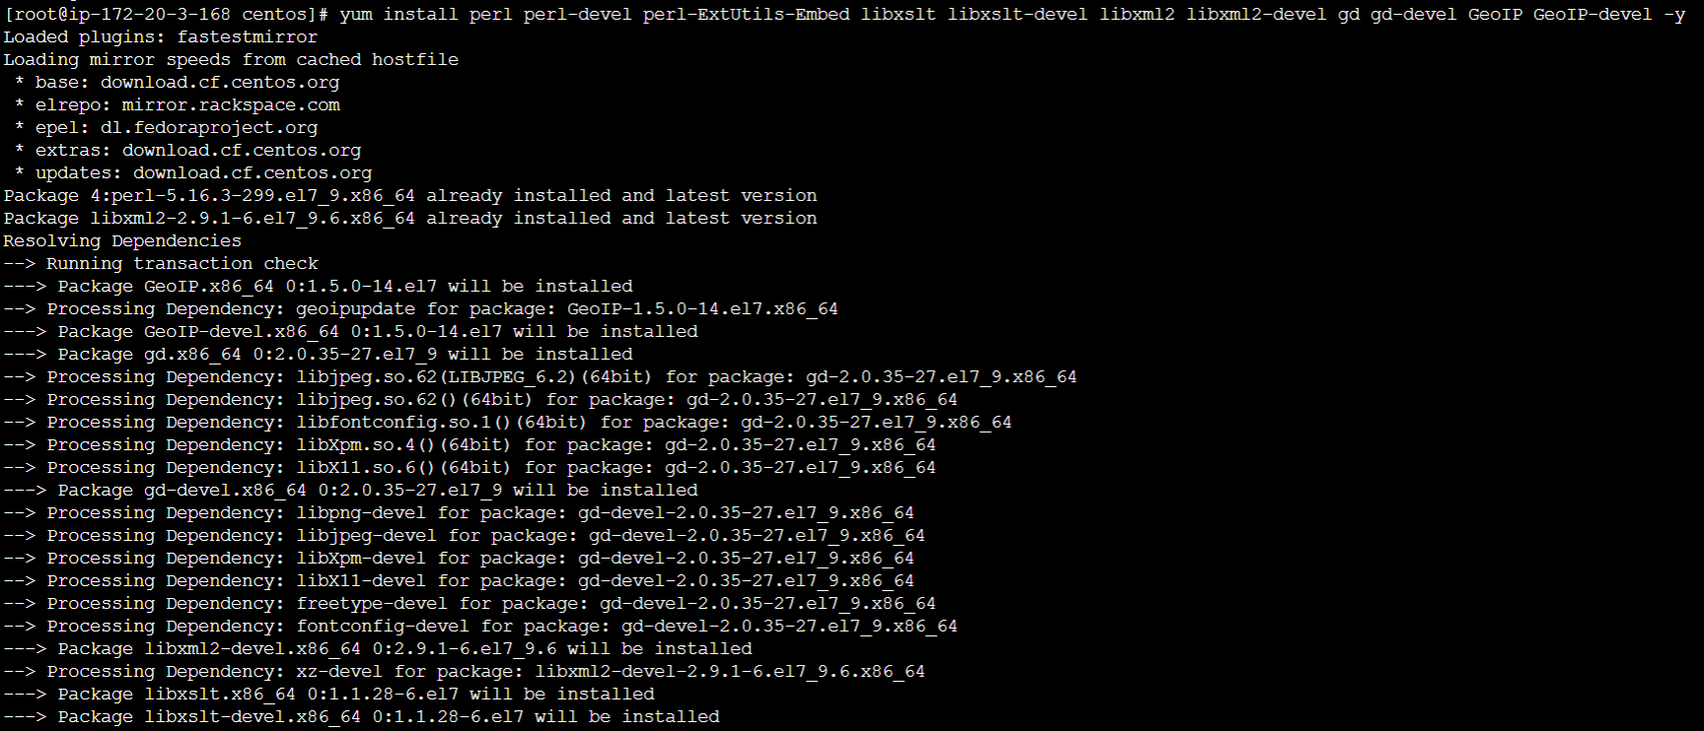

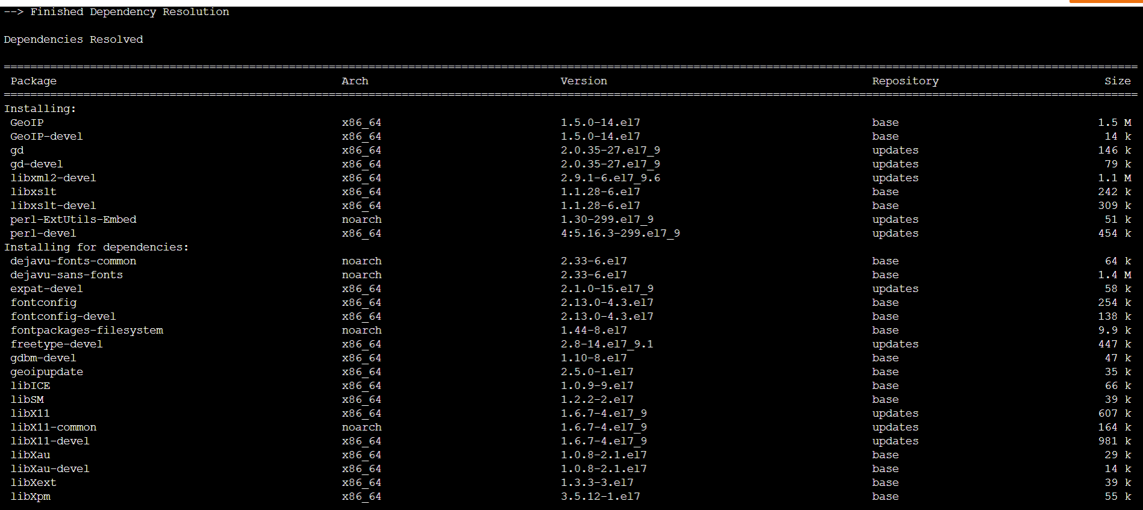

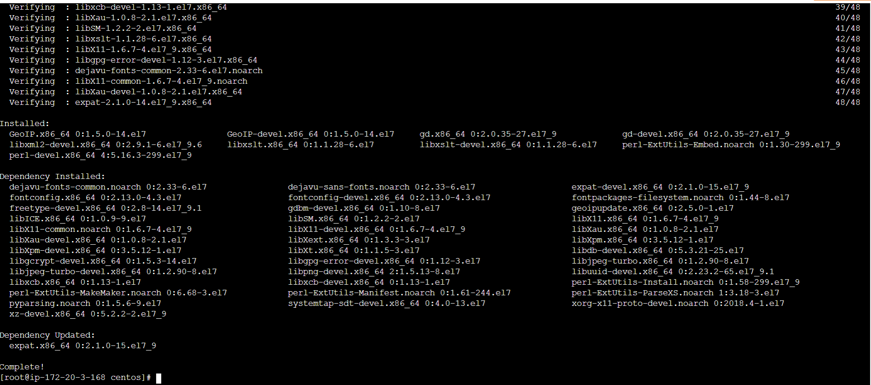

tar -xzf nginx-1.23.1.tar.gz

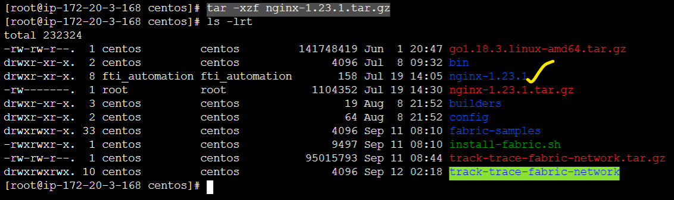

cd nginx-1.23.1

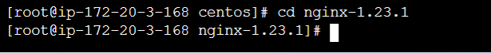

Execute the make command for configuration process.

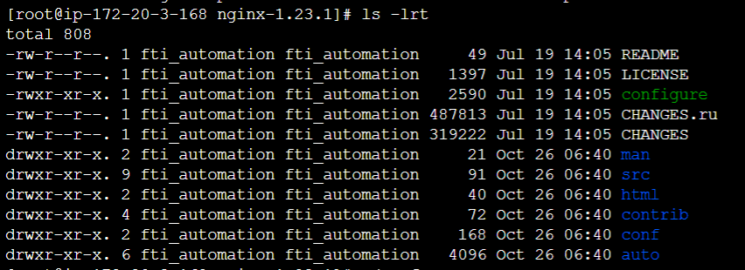

./configure --prefix=/etc/nginx --sbin-path=/usr/sbin/nginx --error-log-path=/var/log/nginx/error.log --pid-path=/var/run/nginx.pid --lock-path=/var/run/nginx.lock --user=nginx --group=nginx

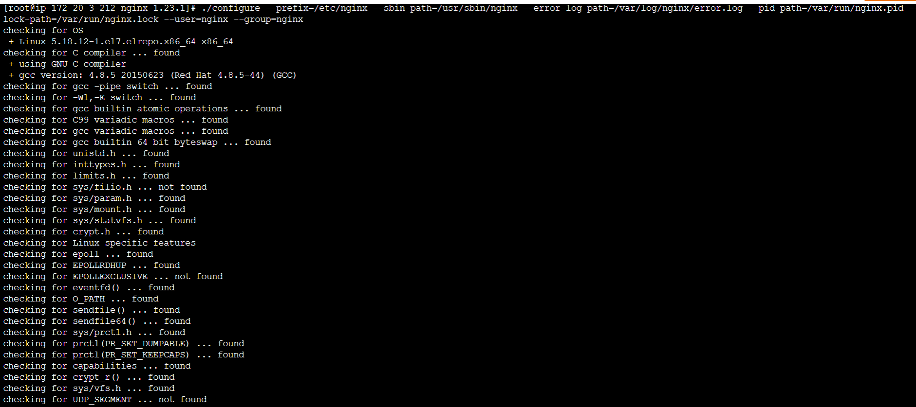

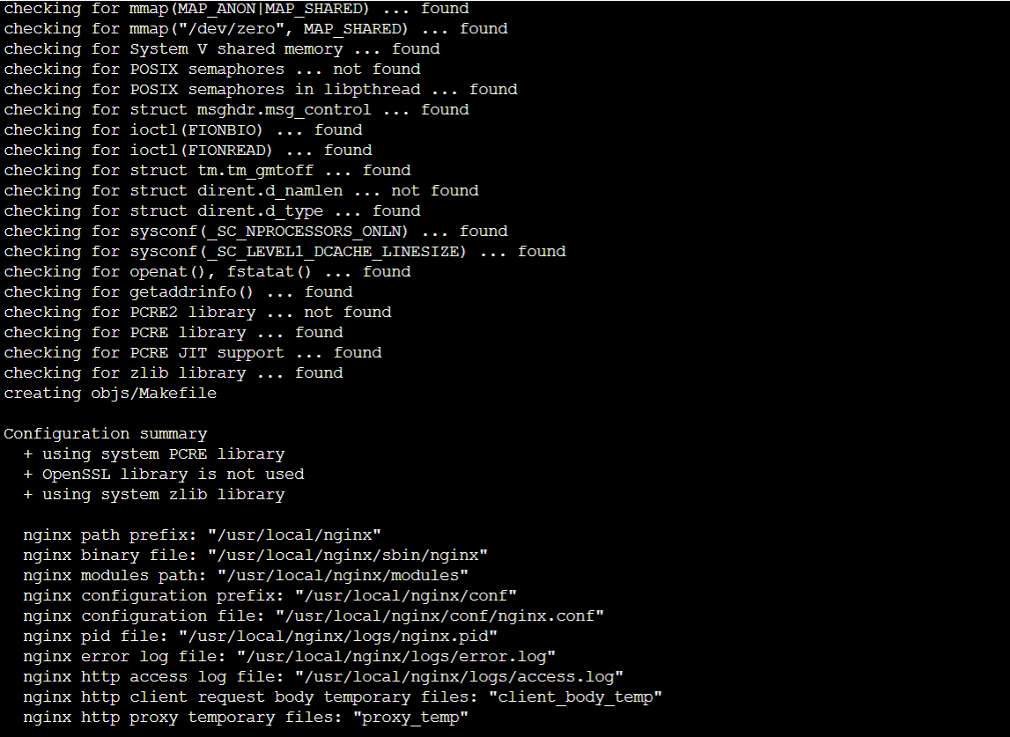

make

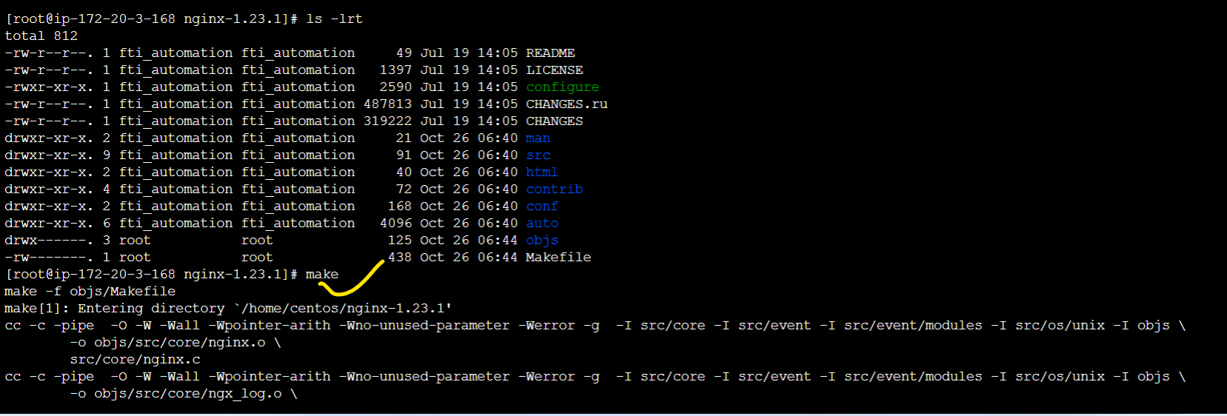

make install

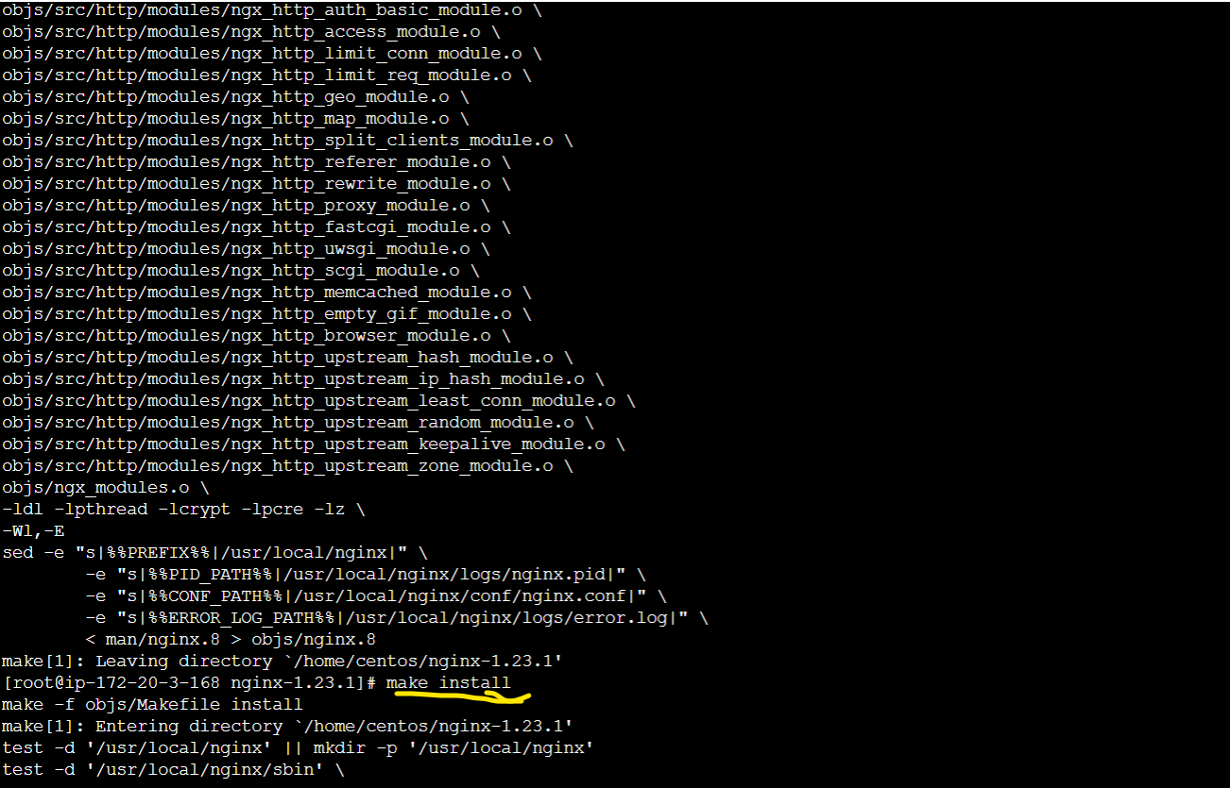

nginx -v



cd ..

useradd nginx

chown -R nginx:nginx /etc/nginx



Configure the service daemon for Nginx by using the vi editor and enter the following content in the file. Save and exit the file.

vi /usr/lib/systemd/system/nginx.service

[Unit]

Description=nginx - high performance web server

Documentation=https://nginx.org/en/docs/

After=network-online.target remote-fs.target nss-lookup.target

Wants=network-online.target

[Service]

Type=forking

PIDFile=/var/run/nginx.pid

ExecStartPre=/usr/sbin/nginx -t -c /etc/nginx/conf/nginx.conf

ExecStart=/usr/sbin/nginx -c /etc/nginx/conf/nginx.conf

ExecReload=/bin/kill -s HUP $MAINPID

ExecStop=/bin/kill -s TERM $MAINPID

[Install]

WantedBy=multi-user.target

Now start and enable Nginx service by running the following command.

systemctl start nginx

systemctl enable nginx

